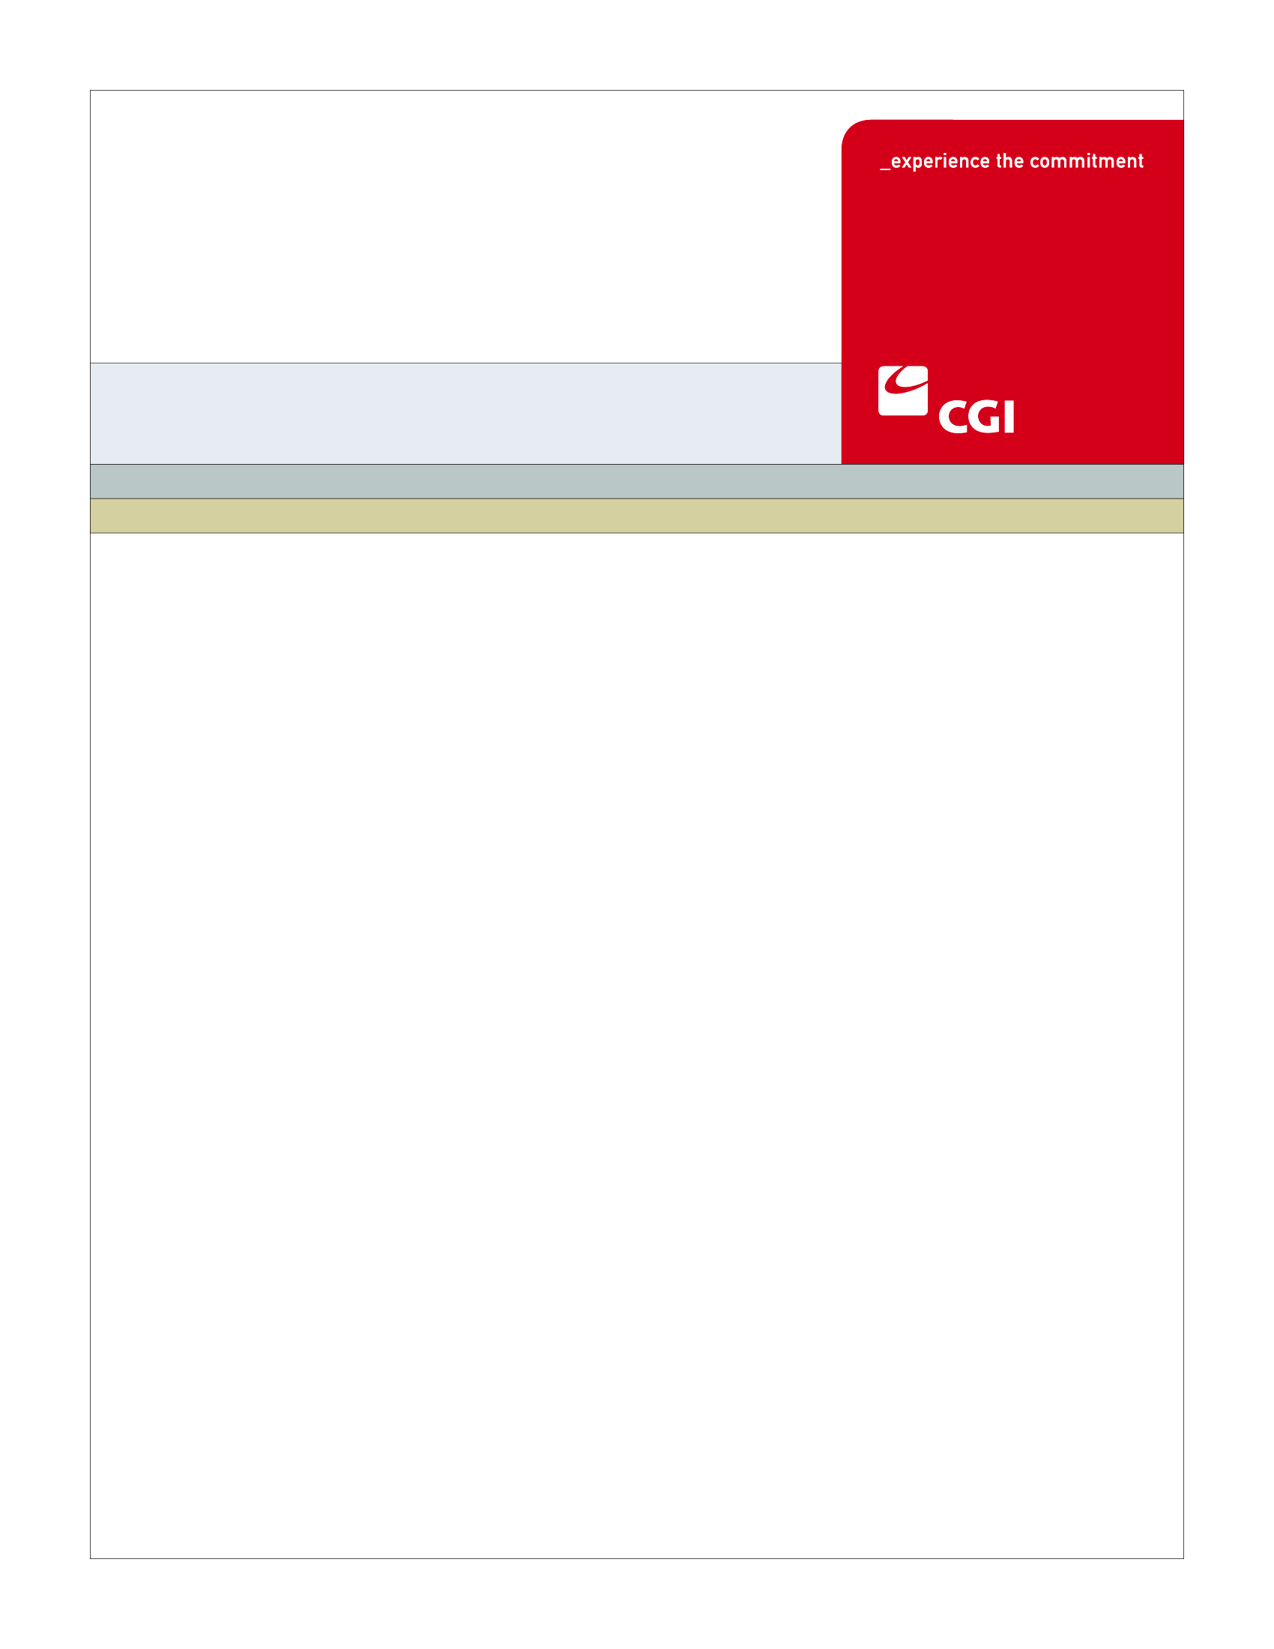USE

**Colorado Health Benefit Exchange (COHBE)**

**EN-001 Participate In Enrollment Period Use Case**

**Version 1.0**

**October 15th, 2012**

REVISION HISTORY

|  |  |  |  |
| --- | --- | --- | --- |
| Version | Date | Modified By | Description |
| 0.1 | 2012-08-15 | Jenny Wu | Initial Draft |
| 0.2 | 2012-09-18 | Raghavan Raghuraman | Post JAD Discovery Session Updates. |
| 0.3 | 2012-09-25 | Raghavan Raghuraman | COHBE Offline review updates |
| 0.4 | 2012-09-27 | Raghavan Raghuraman | Post JAD Verification Session Updates. |
| 0.5 | 2012-10-11 | Jenny Wu | JAD Verification updates due to comments. |
| 1.0 | 2012-10-15 | Raghavan Raghuraman | Post JAD Verification updates from reviews. |
|  |  |  |  |
|  |  |  |  |
|  |  |  |  |
|  |  |  |  |
|  |  |  |  |
|  |  |  |  |
|  |  |  |  |
|  |  |  |  |

TABLE OF CONTENTS

1 Use Case: Participate in Enrollment Period 5

1.1 Goal 5

1.2 Brief Description 5

1.3 Requirements Traceability 5

1.4 Primary Actor 6

1.4.1 COHBE 6

1.5 Secondary Actor 6

1.5.1 Individual 6

1.5.2 Back Office 6

1.5.3 Exchange 6

1.6 Pre-Conditions 6

1.7 Successful Post-Conditions 6

1.8 Triggers 6

1.9 Assumptions 7

2 Flow of Events 7

2.1 Basic (Main) Flow – Participate in Enrollment Period 7

2.1.1 COHBE Establishes Enrollment Period 8

2.1.2 Sets Enrollment Period 8

2.1.3 Is Individual Enrolled? 8

2.1.4 Send Open Enrollment Reminder to Individual 8

2.1.5 Receives Open Enrollment Reminder Notification 9

2.1.6 Does Individual want to take Action? 9

2.1.7 Contacts Exchange 9

2.1.8 Next Steps 9

3 Alternate Flows 9

4 Exception Flows 10

4.1 End 10

4.1.1 Individual does not take action 10

5 Specifications 10

5.1 Business Rules 10

5.1.1 Determination of Open Enrollment Notification 10

5.1.2 Determination of Reminder Notification 10

5.2 Process Rules 11

5.2.1 Is Individual Enrolled? 11

5.3 Workflow 11

5.3.1 Worklist Definitions 11

5.4 UI Screen Details 12

5.4.1 UI Flow Considerations 12

5.4.2 Landing Screen 12

5.5 Communications 13

5.5.1 Imaging Requirements 13

5.5.2 Form Requirements 13

5.5.3 Notices Requirements 13

5.5.4 Other Communication Requirements 14

5.6 Interfaces 14

5.7 Reporting 14

5.8 User Security 14

5.9 Activity Log and Audit Trail 15

5.10 Data Elements 15

6 Future Release Notes 16

7 Appendix A - Glossary 16

# Use Case: Participate in Enrollment Period

## Goal

The goal of this Use Case is for the Individual to be notified by the Exchange that they are able to participate in an open enrollment period and can shop and enroll in plans on the Exchange.

This Use Case completes succesfully when the Individual enrolls during the open enrollment period specified by COHBE.

## Brief Description

This Use Case is only applicable for the open enrollment period for the first year of operation of the Exchange.

COHBE will be able to provide enrollment period information for each line of business to the Back Office staff to update into the Exchange. Once enrollment periods have been established, Individuals will be notified by the Exchange, using their preferred method of communication,that they can enter the Exchange to enroll, i.e., choose their plan of benefits for the upcoming year. The notification will specify the start and end date of the enrollment period in which the Individual will be given to go into the Exchange and choose the plans that they want to enroll in.

If the Individual has or creates an account but does not enroll in a plan (which may be due to inaction) before 30 days prior to the end of the open enrollment period, the user will be sent a reminder that they still can enroll in a plan before the open enrollment period ends. If the notified Individual wishes to take action they may log into their Exchange account and take the necessary steps to shop and enroll in a plan they are eligible for or seek exemption from the Individual Mandate requirement of the Affordable Care Act (ACA) based on, religious or monetary reasons.

## Requirements Traceability

The following requirements are covered within this Use Case:

* EL278: Consumers will be able to enroll in health plans or make changes to their enrollments during open enrollment periods defined by COHBE through configurations in the Exchange (no programming will be required to change or re-define open enrollment periods).
* GF076: Service Representatives will be able to perform all of the activities of the System on behalf of Customers, should Customers need assistance or not have access to the System. Activities of Service Representatives will be limited to the functions required by their roles.

## Primary Actor

### COHBE

COHBE staff will establish enrollment periods for Individuals by sending this information to the Back Office.

## Secondary Actor

### Individual

An Individual will enter the Exchange after receiving the open enrollment notification to shop for available plans to them and proceed on to enrollment.

### Back Office

Back Office staff will assist in configuration of enrollment periods in the Exchange.

### Exchange

The Exchange will initiate the notification to the Individual indicating their open enrollment period is about to begin and send reminder notifications before the close of the Open enrollment period.

## Pre-Conditions

* Medicaid enrollment information has been provided to the Exchange by CBMS.

## Successful Post-Conditions

* The use case is completed once the time frame established in the open enrollment period is completed.

## Triggers

* COHBE determines that an annual enrollment needs to occur.

## Assumptions

There are no assumptions for the Participate in Enrollment Period Use Case.

# Flow of Events

The Business Process Activity diagram below shows the COHBE processes for the Participate in Enrollment Period Use Case. The steps numbered on the diagram below have detailed explanations in the sections that follow.

Figure 1: Participate in Enrollment Period BPM



## Basic (Main) Flow – Participate in Enrollment Period

The Basic Flow through this Use Case will be that the COHBE will indicate to the Back Office that an open enrollment period is required. The Back Office will establish the enrollment period and the Exchange will send reminder messages to Individuals that have accounts on the exchange but have not yet enrolled. Note that for the very first enrollment period there will be an extra reminder sent on December 1, 2013 since the individual mandate starts on the 1st of January 2014 but that the enrollment period does not close until March 31st 2014. Customers who create an account during the enrollment period will also be sent reminders if the account has been created before the reminder are scheduled.

### COHBE Establishes Enrollment Period

COHBE will be able to establish enrollment periods by providing enrollment period information including line of business to Back Office Staff for configuration into the Exchange. The first Open enrollment period for health plans in the Exchange will begin on October 1, 2013 and go through March 31, 2014 for effective dates January 1st, 2014 through May 1st, 2014. The next Open enrollment period is currently scheduled from October 15, 2014 to December 7, 2014 for a January 1st effective date. The Exchange will have an open enrollment period of the entire for dental and vision plans.

The Open enrollment period for a line of business is configurable on the Exchange and may change based on COHBE actions which will be driven by changes in Federal regulations that relate to Open enrollment periods.

### Sets Enrollment Period

Back Office staff receives Open enrollment periods from COHBE and configures the Open Enrollment values into the Exchange. Back office can modify the Open enrollment period on the Exchange based on COHBE directives which will be based on changes in Federal regulations that relate to Open enrollment periods.

### Is Individual Enrolled?

During Open enrollment period, for initial Go Live, the Exchange will be configured to wait until December 1st 2013 to initiate a notification of Open Enrollment to all Individuals who have created an account on the Exchange, have not enrolled in a health plan and have specified a notification method preference. In this step if the Individual is identified as being enrolled by the Exchange (see Process Rule 5.2.1) in a health plan, then the Individual will have no further action to take for the open enrollment period and proceed to the Next Steps, step 2.1.9.

The Exchange will also be configured to send a reminder notification 30 days prior to the end of any open enrollment period that ends. This includes the health plan open enrollment on March 31st 2014 and prior to the end of every subsequent health plan open enrollment period as configured in the Exchange.

### Send Open Enrollment Reminder to Individual

The Individual will also receive a reminder notification (see Business Rule 5.1.2) about the end of their open enrollment period, if they have not already enrolled.

### Receives Open Enrollment Reminder Notification

In this step, the Individual is notified that the open enrollment period is about to end (see Notice 5.5.3.2). The Individual may then proceed to take action in step 2.1.6.

### Does Individual want to take Action?

The Individual in this step may choose to take action after receipt of the open enrollment period notification or reminder notification. If the Individual chooses to take action they may log into their account on the Exchange in step 2.1.7. If the Individual chooses to take no action and have received reminder notification, they proceed to the exception flow, step 4.1.1. If Individual has not enrolled and takes no action, but has not received reminder notification, they will proceed to step 2.1.3.

### Contacts Exchange

The Individual in this step logs into the Exchange account that he/she has created or contacts the Call Center to take action based on the open enrollment period notification and/or reminder notifications. Once the Individual has contacted the Exchange, they proceed to Next Steps (step 2.1.8).

### Next Steps

The Individual would proceed to next steps to continue with enrollment. Next steps could include:

* Shop for Individual Plan – the Individual wants to shop for plan on the exchange.
* Submits Individual Application – the Individual wants to enroll in a Qualified Health Plan (QHP).
* Apply for Exemption – The Individual wants to seek exemption from buying plans on the Exchange.
* Manage Individual Information – The Individual wishes to log into his/her account and modify their information.
* Determine Individual Eligibility – The Individual can perform an eligibility check for themselves and dependents.

# Alternate Flows

There are no Alternate Flows for the Participate in Enrollment Period use case.



# Exception Flows

## End

### Individual does not take action

In step 2.1.6, if the Individual decides not to take any action after having been notified by the Exchange of the Open enrollment period and the reminder notification, then this Use Case ends.

# Specifications

## Business Rules

### Determination of Open Enrollment Notification

The Notice of Open Enrollment being sent out on December 1st 2013 for health plans will be a special circumstance for the first health plan Open enrollment period only.

If the Individual has an account on the Exchange, they will receive notification if:

* The Individual has not sought exemption on the Exchange and
* They have not already enrolled for a health plan during the open enrollment period (Application is not in status ‘Submitted’ or ‘Enrolled’ )and
* The Individual does not have a Medicaid enrollment that includes January 1st, 2014 and
* It is December 1st, 2013.

### Determination of Reminder Notification

* The Individual has not sought exemption on the Exchange and
* The Individual has not already enrolled for the open enrollment period for that plan (Application is not in status ‘Submitted’ or ‘Enrolled’ ) and
* The Individual does not have a Medicaid enrollment that includes the effective date of the open enrollment period.
* It is 30 days from the end of the open enrollment period.

## Process Rules

### Is Individual Enrolled?

In step 2.1.3, the Exchange determines if the Individual is enrolled in a plan for that line of business or is Medicaid enrolled or has sought exemption from the Individual Mandate requirement of the Affordable Care Act (ACA). If the Individual is enrolled in a plan then he/she may proceed to step 2.1.8 and perform actions on the Exchange such as Shop for Individual Plan, or Manage Individual Information. If the Individual is not enrolled in a plan then the Exchange will send notification of the open enrollment period December 1st 2013 and a reminder notification 30 days prior to the end of the open enrollment period.

If the Exchange determines that an Individual has sought exemption from purchasing plans on the Exchange or is Medicaid enrolled then no notification will be sent to them.

This step will be repeated until all necessary notifications have been sent.

## Workflow

### Worklist Definitions

#### Enrollment dates

* Task Name: Intimate Back Office
* Task Actions: Authorized COHBE personnel emails Back Office to inform them about the dates of Open Enrollment period to be setup on the Exchange.
* Comments: This worklist is a placeholder until COHBE procedures are developed and finalized.

#### Setup Enrollment period

* Task Name: Setup Open Enrollment period
* Task Actions: Authorized Back Office personnel access the Exchange and setup the Enrollment period dates on the Exchange.
* Comments: This worklist is a placeholder until Back Office procedures are developed and finalized.

## UI Screen Details

### UI Flow Considerations

There are no UI Flow Considerations for the Participate in Enrollment Period use case.

### Landing Screen

The homepage of the Exchange has the following elements:

* A logo element is shown at the top left of the screen.
* The top frame of the screen has the following elements:

- Find a Plan link/button

- My account link/button

- Learn more link/ button

- Get assistance link/button

* The top banner has the following elements:

- A search link

- A language selection link

- Help link

- A message “Start your application for health coverage”

- A button with the label “Apply”

- Apply for coverage link/button

* The left frame of the screen has a login box with the following fields:
* Username text box
* Password text box
* Remember me checkbox
* Sign in button
* Forgot username or password link
* Create an account button
* The center of the screen has the following elements
* Quick start Eligibility check question
* Primary applicant’s zip.
* Check eligibility for benefits radio button with values Yes and No.
* Start now button
* There is a message displayed at the bottom of the screen

“Various Insurance carriers in the state offer plans through state health exchange that you can purchase for yourself and your family.”

* Learn more link
* At the right frame of the screen on the top section are the following elements:

- View Plans anonymously label

- “Before you apply for coverage, you can find plans available in your area through the state exchange”

* At the right frame of the screen on the bottom section are the following 2 tabs

- News: This tab shows important news like Open enrollment period dates.

- Important dates: This tab shows important dates for the exchange.

## Communications

### Imaging Requirements

There are no Imaging Requirements for the Participate in Enrollment Period use case.

### Form Requirements

There are no Form Requirements for the Participate in Enrollment Period use case.

### Notices Requirements

#### Reminder Notice

* Open enrollment end date.
* Time left before end of Open Enrollment period.
* URL to exchange.
* Dates of next Open enrollment period.
* Individual is notified that special circumstances would be considered for enrollment in a health plan even after the closure of the Open enrollment period.
* Residential address will not be part of the notification if the notification method is email.

### Other Communication Requirements

There are no Other Communication Requirements for the Participate in Enrollment Period use case.

## Interfaces

The CMBS interface will need to be called for Medicaid eligibility data

## Reporting

* User Experience
* Business Activity
* Number of people contacted,
* Number people responding (with aging by contact round)
* Number of people not responding (with aging)
* Workflow
* Community and Public Health

## User Security

* **Actor Status Changes**
* None
* **Sensitive Information Accessed**
* Medicaid Enrollment Data may be accessed to determine if a notice should be sent.
* First Name
* Last Name
* Email Address
* Residential address ( If paper notification is sent)

## Activity Log and Audit Trail

No updates captured at this time.

## Data Elements

| Process Step Reference  **\*Required Field** | Field Name  **\*Required Field** | Required Field? | Action Taken | Actor Performing Action | Format, if known |
| --- | --- | --- | --- | --- | --- |
| 2.1.2 Sets up Enrollment Period | Start Date of Open enrollment period | Required | Create | User | MM/DD/YYYY |
|  | End Date of Open enrollment period | Required | Create | User | MM/DD/YYYY |

# Future Release Notes

* CR32 - The Exchange shall have the ability to automatically re-enroll a subset of Individual Exchange Individuals during the annual Open enrollment period.
* EL279 - At each annual enrollment cycle the Consumer will be able to visit the Exchange and make changes to the Consumer’s health plan enrollment or to renew health plan coverage.
* EL280 - The Exchange will send advance notification to Customers informing them of renewals, open enrollment, and redetermination through their preferred method of communication as noted in their Customer Account Profile. This notification will inform them of their options to use the System to update their profiles (if needed) and conduct the renewal process.
* PS191 - The System shall support automatic renewals at specified timeframes.

# Appendix A - Glossary

| Term | Definition |
| --- | --- |
| Benefits | “Benefits” are to be interpreted as Health Plan Benefits unless otherwise specified in the document. |
| COHBE | Colorado Health Benefit Exchange, “COHBE” is used interchangeably with “Exchange” throughout the documents. |
| Customer or Consumers | “Customers” or “Consumers” may be used interchangeably and are terms meant to define individuals or small employers or employees of small employers learning about opportunities to purchase, shopping to purchase, purchasing insurance through the Exchange, or modifying insurance purchased through the Exchange. References to Customers include, as appropriate, dependents of Customers, employees and dependents of employees and others covered by insurance purchased by Customers through the Exchange. |
| EES – External Eligibility System | The EES, or External Eligibility System is an external service that is called by the Exchange and other state systems (e.g., Peak and CBMS) to determine whether an individual is eligible for various state and federal health care programs including Medicaid and APTC/CSR. |
| Eligibility | “Eligibility” is a broad term that can mean, as an example, one or more of the following:   * An Individual’s ability to purchase on the Exchange * An Individual’s ability to opt out of the Individual Mandate * An Individuals entitlement to advanced premium tax credits or cost sharing reductions (“MAGI Eligibility”) * An Employer’s ability to use the SHOP Exchange to provide employees with health insurance options * An Employer’s entitlement to premium tax credits * A Carrier’s ability to offer QHP’s through the exchange   Unless specifically stated as “MAGI Eligibility”, the term Eligibility should be interpreted as broadly as possible within the context of the requirement. |
| Eligibility Determination | “Eligibility Determination” is the process of determining an Individual’s eligibility for various programs (including Medicaid, CHP, APTC and CSR) using the External Eligibility Service (EES). The determination may be either preliminary or final depending on when the EES is called (either at preliminary screening stage or after application has been completed). |
| Employee | An “Employee” is a person who is employed by a company or small business who obtains insurance through the Exchange. |
| Employer | An **“Employer”** is a company or small business who participates in the Exchange to offer insurance and/or premium assistance to its Employee(s) or its Employee(s) and their dependents. |
| Enrollment | **“Enrollment”** occurs when a Carrier accepts an Application and commits to providing healthcare benefits to the applicant(s) within the provisions of a healthcare coverage plan. |
| Exchange | During the implementation phase, the terms “Exchange” or “Exchanges” are meant to include technology, services, business processes, people, and other resources required to implement, operate and/or maintain the requirements or functions needed to support the ability for consumers to shop for and purchase health insurance. Specifically related to interpretation of a requirement, the term “Exchange” implies that the implementation of a requirement is not strictly limited to a technology solution.   * Individually, the term “Exchange” refers to each Exchange or both Exchanges as appropriate in the context. * The Exchange is NOT a state agency but a standalone non-profit entity. It will serve as an aggregator of individual policies sold by private insurers and underwritten using the new federal and state underwriting and rating rules. * The Small Business Health Options Program (SHOP) Exchange will support the specific needs of small employers. * For context, the Exchanges will act much like an “Expedia or Orbitz for Health Insurance” system. They will allow individuals and small firms to obtain information, compare and purchase private health insurance plans. The Exchanges will also be the entities that will evaluate whether or not a particular insurance policy meets the criteria set out by the new federal rules for policies offered to individuals and small employers. |
| Individual | “Individual” is generally meant to identify a person who obtains insurance for themselves and/or their dependents through the Individual Exchange. |
| Navigators | “Navigators” are persons authorized to assist Customers in their activities to shop for insurance through the Exchanges. |
| Notification | For the purposes of the implementation phase of the program, the term “**Notification**” or “**Notices**” shall mean a formal written document that is sent to Customers or Carriers regarding products or services offered on the Exchange. |
| Qualified Health Plan (QHP) | “Qualified Health Plan (QHP)” generally refers to health plans that meet all the criteria set forth by CMS, the DOI and the Exchange and are offered on the Exchange. In some instances, QHP means both the carrier offering the plan and the plan itself. |
| **Service Representative** | Service Representative (ServRep or SR): A COHBE representative who assists Participants, Customers, and/or Users in using the Exchange and/or the System. **NOTE**: **CSR** is used to mean Cost Sharing Reductions and shall **not** be used to mean ‘customer service representative’. |
| System | The “System” means all of the software, configurations, data, processes, and equipment used to provide the Exchanges and the System is also referred to as the “solution.” During the implementation phase, “System” is taken to mean the technology component of the Exchange. |
| Users | “Users” are users of the Exchange authorized by COHBE and may include operators, administrators, customers, brokers, navigators, etc., who interact with the System. Users may be internal or external to COHBE. |